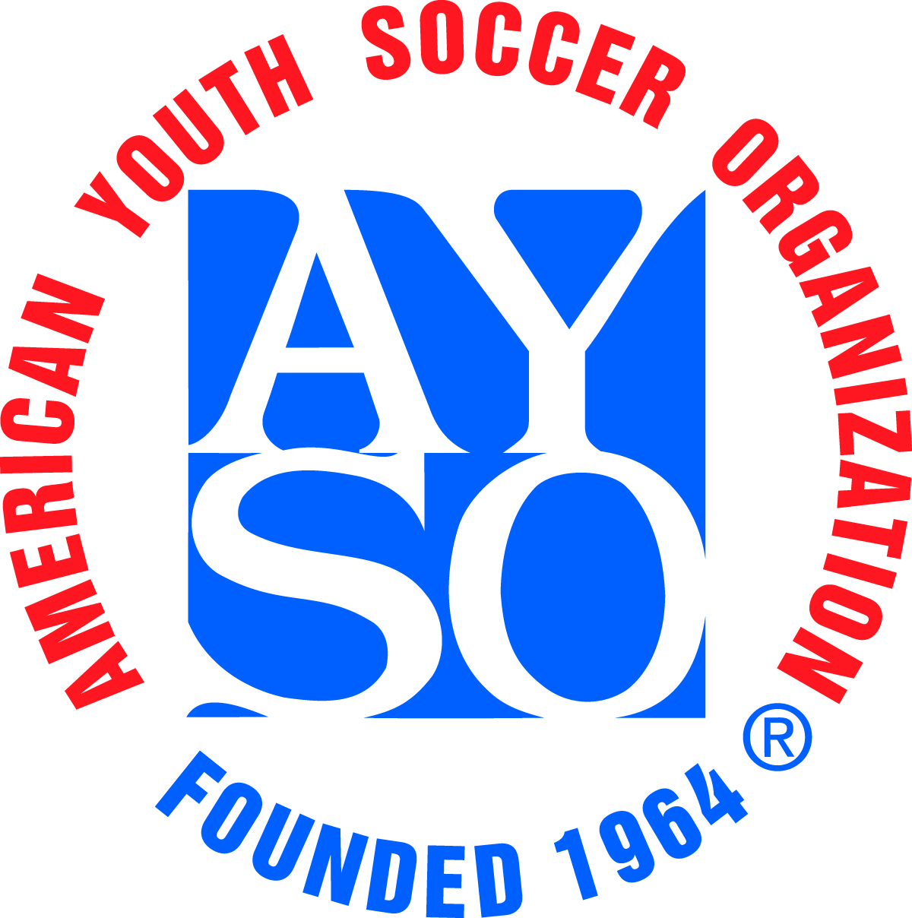 |  | AYSO All American Tournament Team Roster |  |  |  |  |  |  |  |  |  |  |  |  |  |  |  |  |  |  |  |  |  |  |  |   Tournament Logo Here
 |  |  |  |  |  | Roster Date:
Region: |  |  |  |  |  | Team Name:
Coach Name: |  |  |  |  |  |  |  |  |  |  |  |  |  |  |  | Safe Haven Date |  |  |  |  |  | Training Level
Asst. Coach Name: |  |  |  |  |  |  |  |  |  |  |  |  |  |  |  | Safe Haven Date |  |  |  |  |  | Training Level
Uniform Colors: Shirt: |  |  |  |  |  |  |  |  |  |  |  | Shorts: |  |  |  |  |  |  |  | Socks:
Age Division: |  |  |  | U-10 |  |  |  | U-12 |  |  | U-14 |  |  |  | U-16 |  |  | U-19 |  |  | Boys |  |  |  | Girls |  |  | Coed

Maximum # of Players: |  |  |  |  |  | eAYSO Roster Note: You are encouraged to submit an eAYSO roster in lieu of this roster form. If you do, make sure the Regional Commissioner signs that form. If you also will be bringing Guest Players, you will need to use the separate Guest Player Form.
U-10 | U-12 | U-14 | U-16 | U-19
10 | 12 | 15 | 18 | 18

Directions: Player ID #: The National AYSO Registration Number, Region #: Region in which player is registered.

(List In Order By Uniform Shirt No.)
Shirt  # | Region  # | Player ID # | Player’s Name  Last, First (please print) | Age | Date of Birth | Telephone  Including Area Code
By my signature below, I certify that all players on this roster are valid registered players in my region and are approved to participate in this tournament:
Regional Commissioner:
Print Name Signature (Blue Ink)
Guest Player(s) Regional Commissioner:
Print Name Signature (Blue Ink)

